**Open PO Report:**

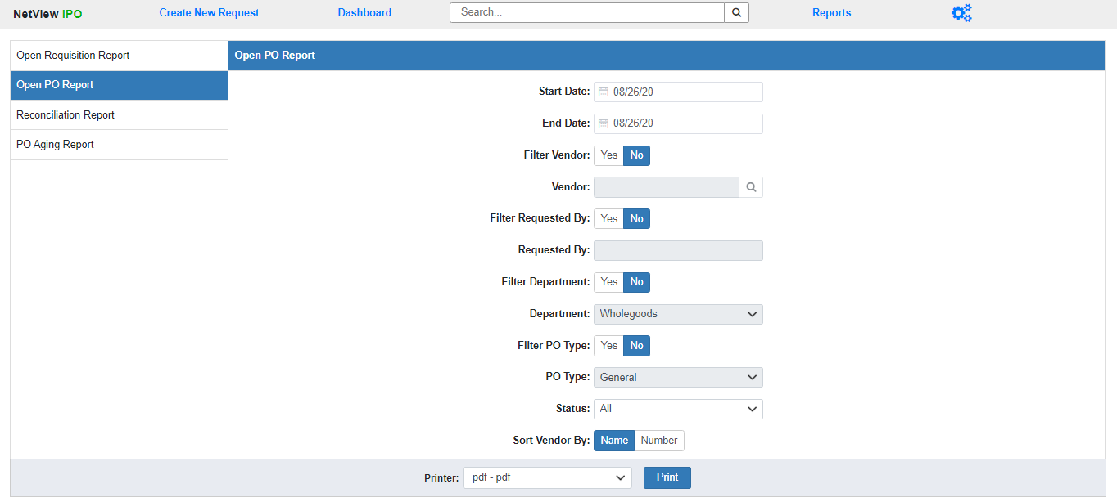

The Open PO Report lists all Open Purchase Orders (POs) at your dealer location during a set time period. You can use the fields displayed to run the report for specific items, such as viewing all the Open POs for a single vendor or for a specific Department.

**Field Definitions:**

Start/End Date: Enter the start and end dates for your desired time period. The report will include all POs that had an Open status during that time period. Both fields default to the **current** date.

Filter Vendor: Select **Yes** to run the report for all Open POs belonging to a specific vendor. Select **No** to run the report for all vendors.

**Vendor:** This field will activate if you choose to filter the report by vendor. Enter the Vendor Number you wish to run the report for or use the Search option to look it up by entering part or all of the vendor’s name.

Filter Requested By: Select **Yes** to run the report for all Open POs created by a specific user. Select **No** to run the report for all creation users.

**Requested By:** This field will activate if you choose to filter the report by the creation user. Enter the desired user’s ID here. **NOTE:** If the ID you enter doesn’t exist in the system, you will receive a **blank** report.

Filter Department: Select **Yes** to run the report for all Open POs belonging to a specific Department. Select **No** to run the report for all Departments.

**Department:** This field will activate if you choose to filter the report by Department. Select the desired department from the drop-down menu. The options will be all Departments that currently exist in your system.

Filter PO Type: Select **Yes** to run the report for all Open POs with a specific PO Type. Select **No** to run the report for all PO Types.

**PO Type:** This field will activate if you choose to filter the report by PO Type. Select the desired type from the drop-down menu: General, Unit, or Part.

Status: Use this field to choose what Open PO status you want to run the report for:

* **All:** Runs the report for all Open POs regardless of status.
* **Ordered:** Runs the report for all Open POs that have at least been fully Ordered.
* **Received:** Runs the report for all Open POs that have had at least 1 line go through the Receive step or further (up to Completed lines, as long as the PO itself is not closed).

Sort Vendor By: The report is sorted by the PO Vendor, and lists both the Vendor Name and the Vendor Number. Use this option to select if you want the report sorted by Vendor Name or Vendor Number. The report sorts by **Vendor Name** by **default**.

**Printer:** Select the printer to receive the report. Use the **pdf** printer to view the report before printing.

**Click “Print” to run the report.**

**Sample Report:**

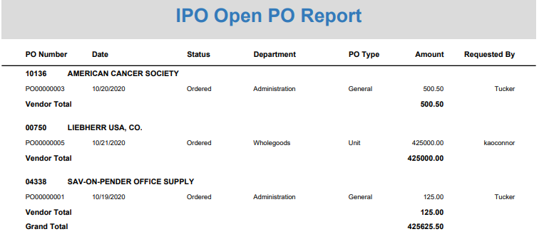

The report is divided into sections by **vendor**, with each section beginning with a line listing the vendor number and name.

Report Columns:

**PO Number:** This column shows the PO number.

**Date:** This column shows the document date.

**Status:** This column shows the Open PO’s status

**Department:** This column shows the document’s Department.

**PO Type:** This column shows the PO Type (General, Unit, or Part).

**Amount:** This column shows the PO amount.

**Requested by:** This column shows the name of the user that created the PO.

Vendor Total: A total line for the Amount column appears after the last PO entry for each vendor, letting you know the total value of all the vendor’s Open POs.

Grand Total: This line appears at the end of the report and provides the total dollar amount of all Open POs on the report.